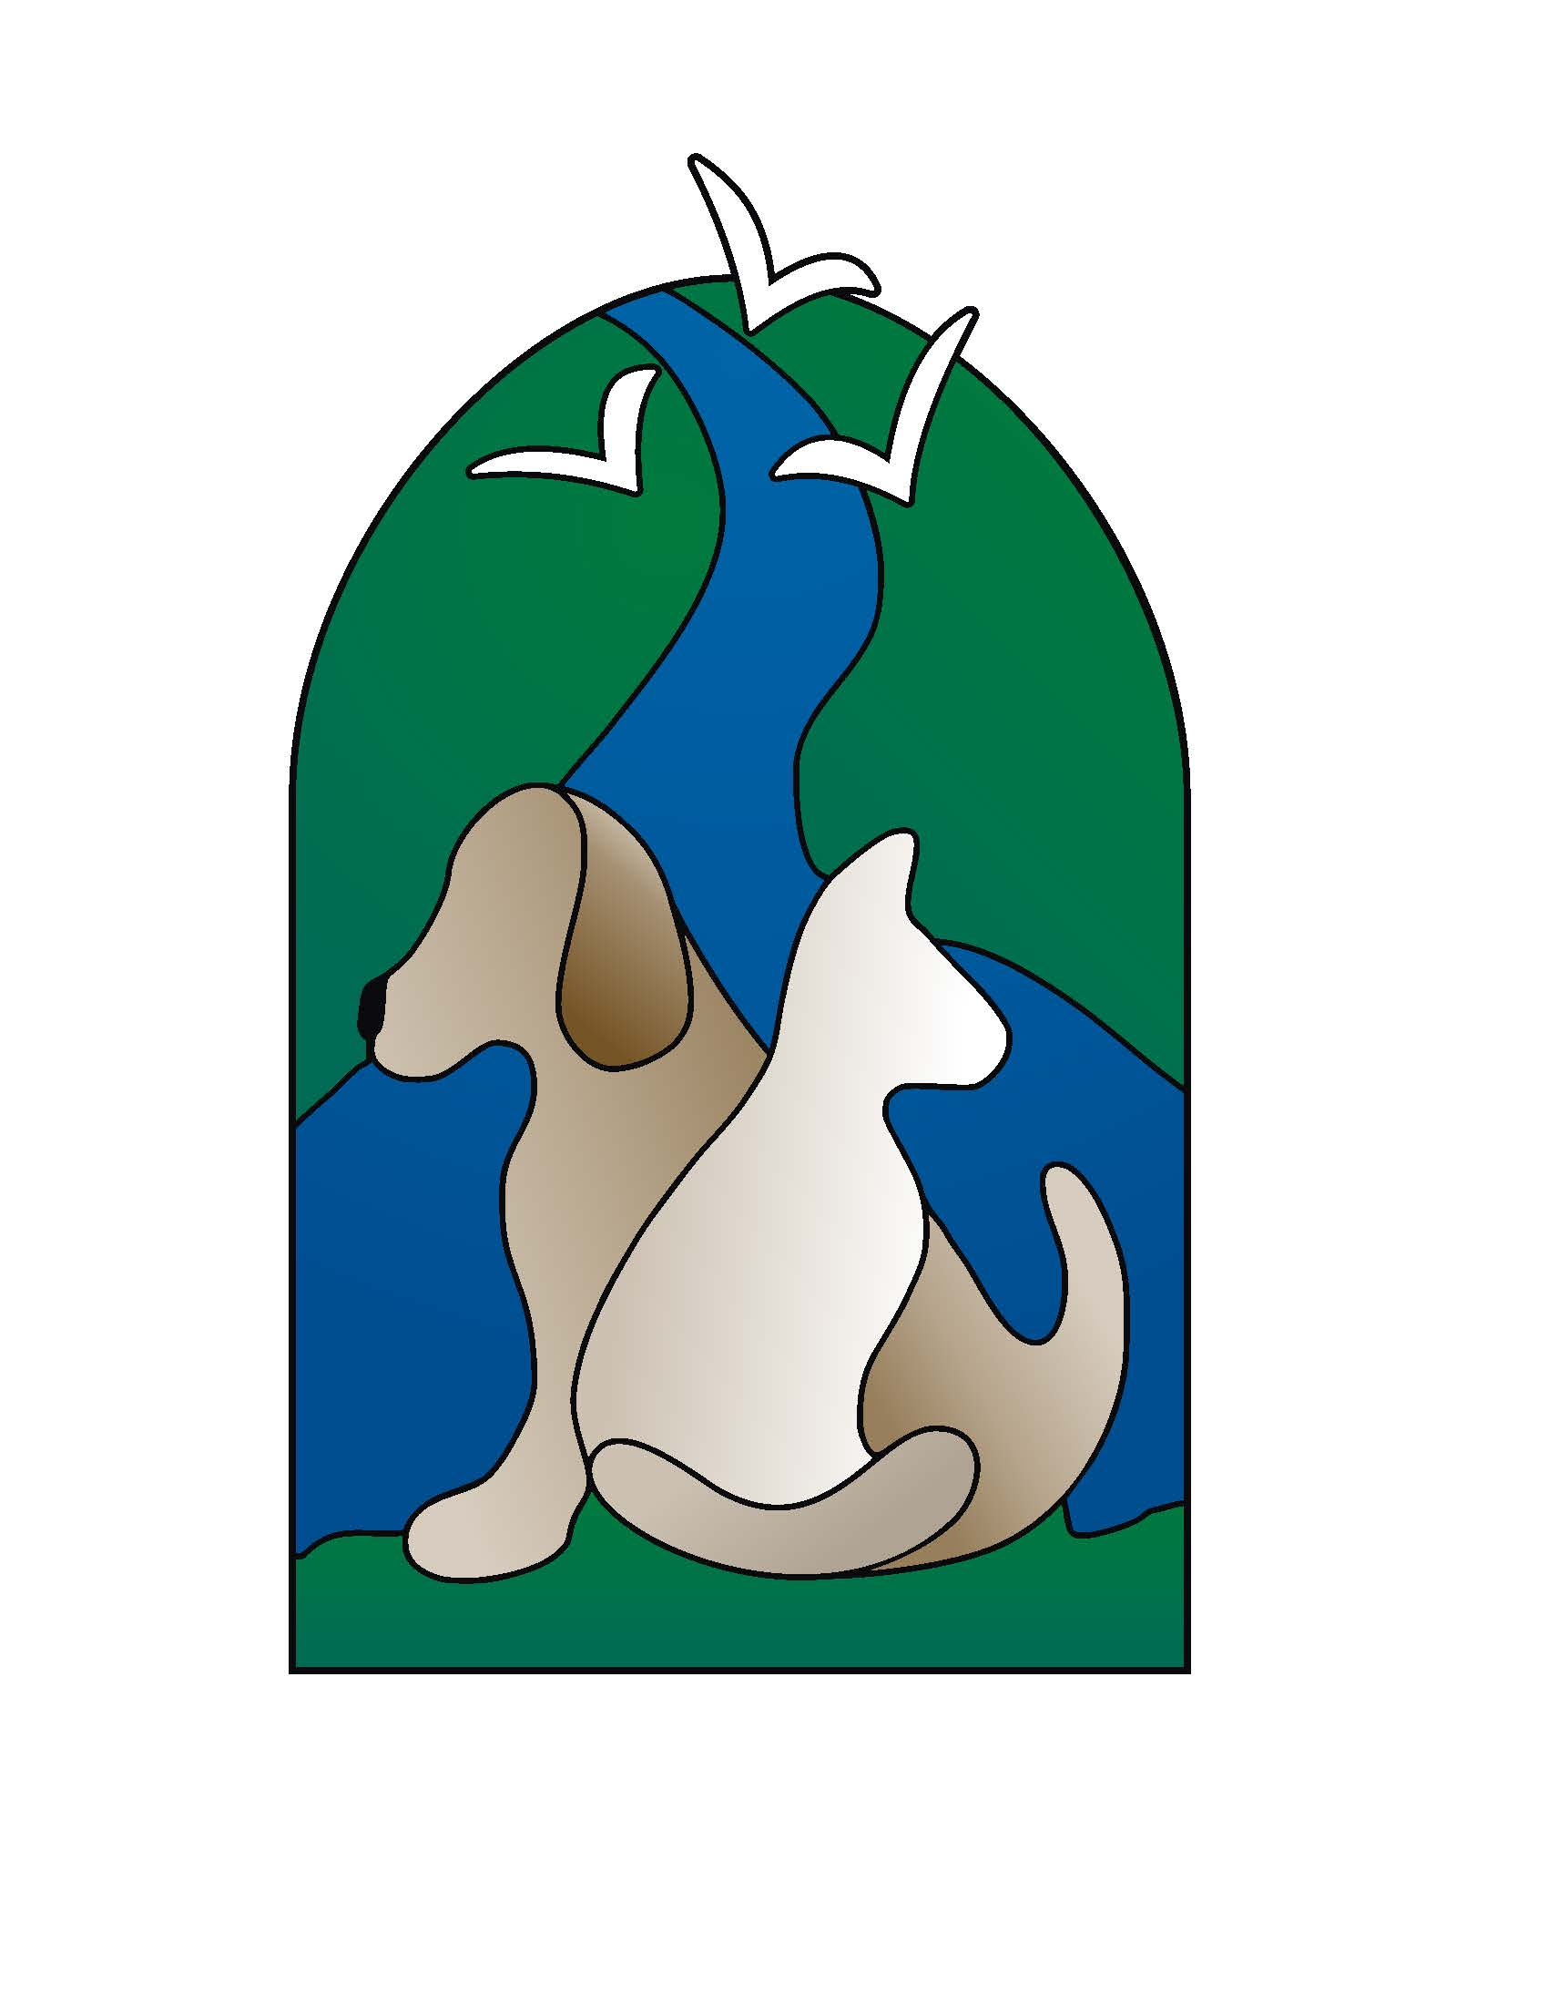 |  | Dove Creek Animal Hospital  1200 Bent Oaks Court  Denton, Texas 76210  Phone: 940-387-3313  www.dovecreekanimalhospital.com |  |  |  |  |  |  |  |  |  |  | PET EXAMINATION REPORT CARD
PET INFO: |  | Name: |  |  |  |  | Age/DOB: |  |  |  |  |  | Canine Feline |  |  |  | Breed: |  |  |  | M F
OWNER INFO: |  | Name: |  |  |  |  |  |  |  |  |  |  | Phone Number:
Reason For Visit:
Weight: ______ Underweight Normal Overweight |  |  |  |  |  |  |  | Temperature: ______ Low Normal High
Neutered:  Energy:  Appetite:  Water Intake:  Urination:  Feces:  Vomiting:  Coughing:  Sneezing: | No Yes  Normal Increased Decreased  Normal Increased Decreased None  Normal Increased Decreased None  Normal Increased Decreased None  Normal Other: _____________ None  None Yes, frequency _______  None Yes, frequency _______  None Yes, frequency _______ |  |  |  |  |  |  |  |  |  | ROUTINE TESTS  Heartworm Test  FELV Test  FIV Test  Fecal Exam  Other: |  |  |  |  | RESULTS  Positive Negative  Positive Negative  Positive Negative  ____________________  ____________________ |  |  |  | VACCINATIONS GIVEN  DHLP – P  Rabies (1yr / 3yr)  Bordetella  FVRCP  Leukemia  Other: ___________
HEART  Seems Normal |  |  |  | LUNGS  Seems Normal |  | EYES  Seems Normal |  |  |  |  |  |  |  | EARS  Seems Normal |  |  |  |  | NOSE / THROAT  Seems Normal
Heart Rate: ______  Slow  Normal  Fast  Murmur L __ R __ |  |  |  | Crackling  Rapid Breathing  Coughing  Wheezing  Tracheitis  Congestion  Labored |  | Discharge  Entropion  Corneal Ulcer  Cataracts  Lid Growth |  |  |  | L__ R__  L__ R__  L__ R__  L__ R__  L__ R__ |  |  |  | Scaly Border  Ear Mites  Excess Hair  Excess Wax  Exudate  Inflamed  Pus |  |  |  | L__ R__  L__ R__  L__ R__  L__ R__  L__ R__  L__ R__  L__ R__ | Dry / Crusty  Enlarged Tonsils  Enlarged Lymph Glands  Nose Discharge L__ R__
MOUTH / TEETH / GUMS  Seems Normal |  |  |  |  | 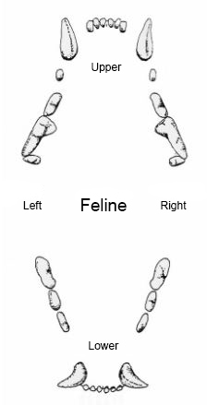 |  | 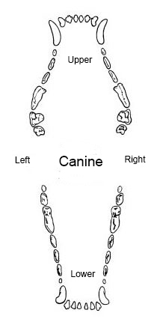 |  |  |  |  | ABDOMEN  Seems Normal |  |  |  |  |  |  | MUSCULO - SKELETAL  Seems Normal
Loose Tooth  Broken Tooth  Stained Tooth  Pale Membranes  Tartar  Mild / Moderate / Severe  Gingivitis  Mild / Moderate / Severe |  |  |  |  |  |  |  |  |  |  |  | Abdominal Mass  Ascites  Tense  Hernia Umbilical__ Inguinal__ |  |  |  |  |  |  | Pain  Nail Problem  Lameness  Joint Problem(s)  Location(s):  _______________________
SKIN / HAIR COAT  Seems Normal |  |  |  |  |  |  |  |  | RECOMMENDED TESTS / TREATMENTS
Dull / Dry  Excess Shedding  Scaly  Scabs  Hair Loss  Matted  Hot Spot  Staph Infection |  |  | Abscess  Cyst  Fleas  Tumor  Wart  Excessive licking of paws  Ticks  Mange Mite |  |  |  |  |  | X-Rays  EKG  Urinalysis  Thyroid Level |  |  |  |  |  | Teeth Ultrasonic Cleaning  Drug Monitoring  Blood Screen  Deep Ear Video
Follow Up: ______________

Other: _________________________________________________
COMMENTS: ___________________________________________________________________________________________________

_______________________________________________________________________________________________________________

Vet Tech: _____________________________ Veterinarian: ______________________________ Date: __________________

